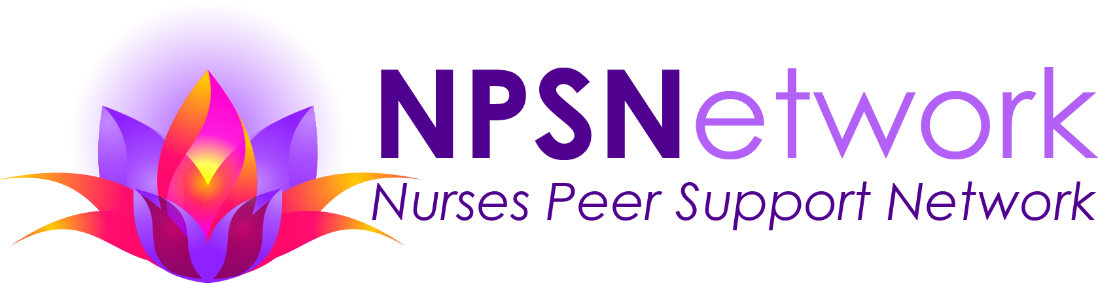
MISSION: To be a resource for all Minnesota nurses affected by substance use disorders, while fostering public safety through outreach and education.

“I need the support of other nurses in recovery to keep strong in my own recovery. Professional understanding helps to fortify me” Nurse Participant

VISION: All nurses in Minnesota will have access to peer support for substance use disorders in a confidential and caring environment. Through education shame and stigma in addressing substance use disorders will be eliminated.

“I can’t tell you how grateful I feel to have these NPSN meetings to attend. It is a safe place.” Nurse Participant

NPSN is guided by a set of VALUES:
- Bold and innovative action in support of our mission/vision of confronting stigma and shame and educating wisely.
- Collaboration means NPSN is inspired and strengthened through inclusive partnerships with individuals, organizations, and our diverse community.
- Honesty by holding NPSN to the highest standards of integrity in program and fiscal accountability.
- Gratitude for NPSN participants, volunteers, donors, board and staff and acknowledge that each individual plays an important role in the success of this organization.

“Knowing other nurses have the same disease and seeing their struggles and solutions has been an inspiration and comfort for me.” Nurse Participant

WHAT WE DO:
- Provide group, one-to-one and online peer support throughout the state for Minnesota nurses recovering from substance use disorders.
- Advocate that nurse education programs and nurse educators provide students background and information about risk factors and consequences for substance use.
- Present educational opportunities for organizations of nurses, nurse employers and the general public about substance use disorders. NPSN offers a Speaker’s Bureau to any group interested in learning more about substance use disorders in nursing and the value of peer support.

CONTACT INFORMAITON: NURSES PEER SUPPORT NETWORK

WEB SITE: www.npsnetwork-mn.org
FACEBOOK: www.facebook.com/npsnetwork/
EMAIL: info@npsnetwork-mn.org
minnesotanpsnetwork@gmail.com

PHONE: 612-508-3709

EVERY NURSE DESERVES ACCESS TO TREATMENT, HELP IN PRESERVING HIS OR HER LICENSE AND EMPLOYMENT STATUS, AND ONGOING SUPPORT BY PEERS THROUGHOUT THE RECOVERY PROCESS.

“Knowing I am not alone in this struggle – hearing similar stories from people with similar backgrounds and with similar passions and aspirations has been incredible.” Nurse participant

9212019

